Brian Stoiber

Object Oriented Design

**Final Project Installation/Setup Instructions**

The instructions below are based on a Microsoft Windows 10 installation. Installation on Mac OSX or Linux will vary slightly.

**NetBeans**

After doing a lot of reading online, NetBeans seemed to work a little better with Scene Builder and modifying FXML files. Because of that I switched to it from using Eclipse.

1. Download NetBeans (Java SE)
   1. <https://netbeans.org/downloads/>
2. Run *netbeans-8.2-javase-windows.exe* and install it on your system

**Scene Builder**

I used Scene Builder for creating the FXML files that are used for the GUI in the asset management system.

1. Download Scene Builder
   1. <https://gluonhq.com/products/scene-builder/>
2. Run *SceneBuilder-10.0.0.exe* and install it on your system
3. Install *fontawesomefx* libraries
   1. Enter the JAR/FXML Manager by clicking the setting gear next to Library

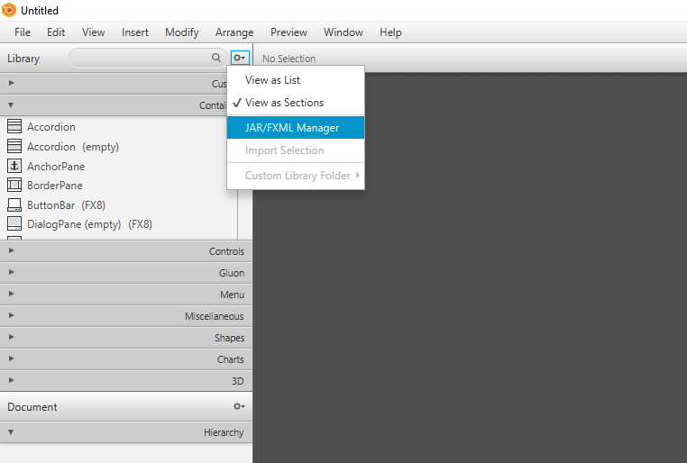

* 1. Click **Search repositories**
  2. Under “Group or artifact ID” enter *jfoenix* and click **Search**
  3. Select *com.jfoenix:jfoenix* and click **Add JAR**

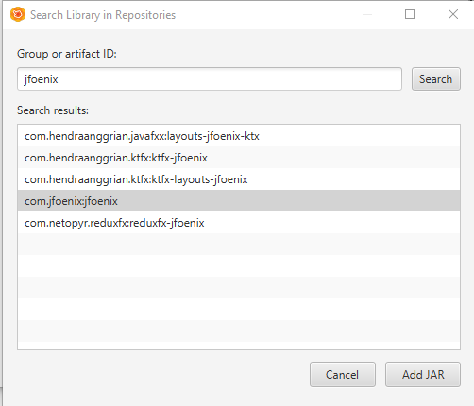

* 1. Click **Import Components**

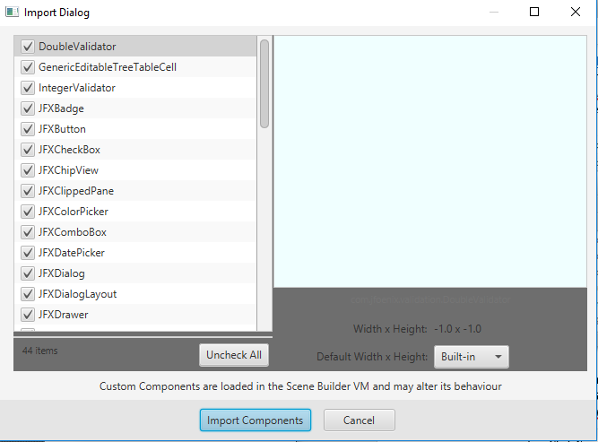

* 1. Click **Search repositories**
  2. Under “Group or artifact ID” enter *fontawesome* and click **Search**
  3. Select *de.jensd:fontawesomefx-fontawesome* and click **Add JAR**
  4. Click **Import Components**

**Install Apache Maven**

I used Apache Maven for the database which stores assets, employees, and vendors in the application.

1. Download Apache Maven (Binary zip archive)
   1. <https://maven.apache.org/download.cgi>
2. Run *apache-maven-3.5.4-bin.zip* and extract into C:\Program Files\
3. Set environment variables
   1. Click Windows button and type *Environment* and select **Edit the system environment variables**
   2. Click **Environment Variables**
   3. Under “System Variables” click **New**
   4. Under “Variable name” enter *MAVEN_HOME*
   5. Under “Variable value” enter C*:\Program Files\apache-maven-3.5.4*

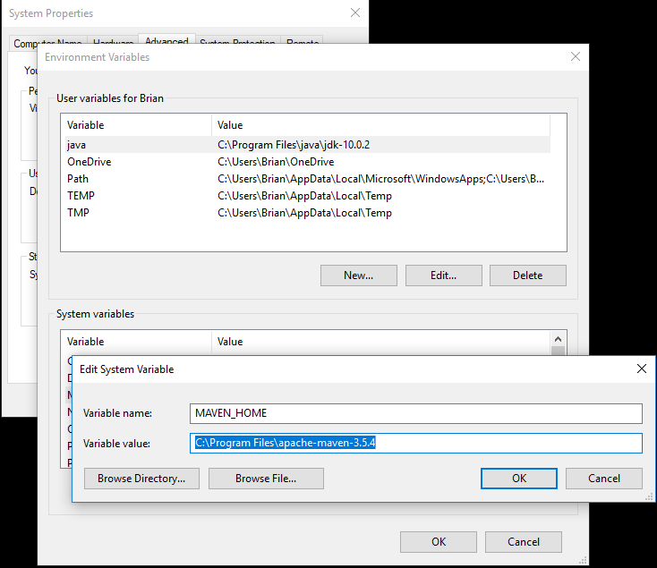

* 1. Click **OK**
  2. Select *Path* and click **Edit**
  3. Click **New**
  4. Enter *%MAVEN_HOME%\bin*

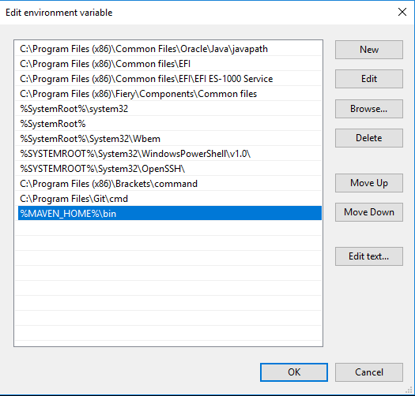

* 1. Click **OK**
  2. Open a command prompt and type *mvn -version* and click **Enter**
  3. The response should read *Apache Maven 3.5.4….*

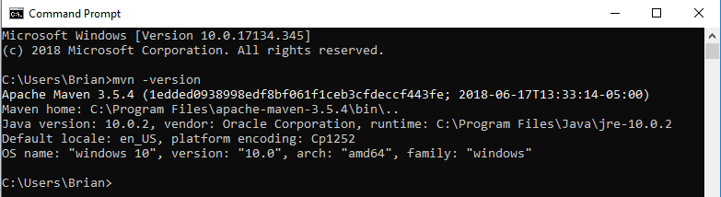

**Install MySQL Community Server**

1. Download and install MySQL Community Server
   1. <https://dev.mysql.com/downloads/mysql/5.7.html#downloads>
2. Create a new connection Record hostname, port, username, and password
   1. Create a new database using the command: (*create database assetmgmt;)*
3. Modify application.properties to reflect the values you use to create the connection

**Build/Run Project**

1. Right click on project folder and select **Run as** / **Maven install**
2. Right click on project folder and select **Run as** / **Java Application**